|  |  |  |  |
| --- | --- | --- | --- |
| Module Code | DWD 504 | Module Title | DWD 504 Database Concepts |
| Student ID | 3201807 | Name | Jack Bradley-Coombes |

Task 1: Entities and attributes

|  |  |
| --- | --- |
| **Entity** | **Attributes** |
| **Customer**  to store relevant customer details | Customer_ID, first_name, Last_name, mobile_number, email_address, adress |
| **Categories**  Categorization of products. | Category type (Sports_Car, Family_car, luxury_car.) Category_ID, category_name, |
| **Employees**  To store relevant employee details | First_name, Last_Name, Employee_ID, mobile_number, email_address, branch, job ( which branch they work at and what their job is at the branch, date_hired, Salary |
| **Invoice**  Tracking of payment details. | Invoice_ID, payed_date, due_date, price (cost of the payment before tax), tax, Total (total cost) payment_type |
| **Product**  Details about specific products, so it’s easy to reference and check details about specific products | Product_ID, Product_name, stock, price, warranty, discount |
| **Order**  Details about the order, referenced later in the purchase phase. | Order_ID, Order_Type (online or in person order), Order_date, Salesperson |
| **Discounts**  Discount Details | Discount_ID, Discount_value, Discount_Name |
| **Delivery**  Delivery details | Shipping_ID, Shipment_Date, Delivery_method |
| **Warranty**  Warranty Specifications | Warranty_duration, warranty_provider, warranty_id |

Task 2: Business Rules

1. Under the **‘Category’** types section, it should include either: family cars, luxury cars, and sports cars.

2. It should be included in the **Product** information section that cars being sold can be used or new.

3. **Payment** can be either direct payment, or situationally a monthly invoice, where you receive the payment in parts over 5 years.

4. The salesperson who makes a sale should be recorded for their commission-based payment under the purchase **order** details.

5. New cars come with 4 years of Mechanical warranties from the manufacturer, this should be noted under the **warranty** section.

6. In a single sale **order,** the customer can trade in no more than one of their used cars but can purchase any number of cars.

7. **Employees** can only work under one of three branches, Auckland, Hamilton, or Wellington.

8. **Employee** types include full-time salespeople, part-time salespeople, an admin staff, and branch managers.

9. All **employees** work on a salary-based payment, however salespeople receive a commission-based payment on top, where they receive extra payment depending on how many sales they make.

10. The company has a weekly **discount** system where a few select cars are discounted. This can affect the final price of the sale.

Task 3: Entity Relationship Model

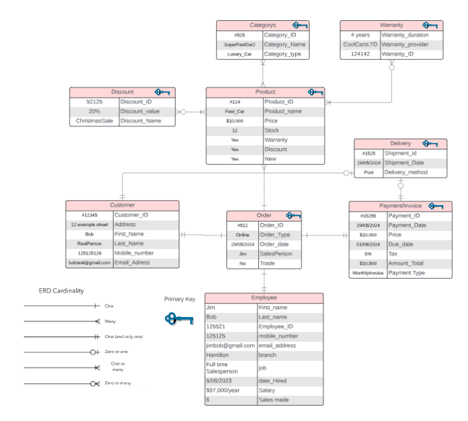

Should this not be readable, a link to the lucid chart is here. [Safeco Cars Lucid Chart](https://lucid.app/lucidchart/469e85ad-a671-4d43-a1a6-074b0364f2a6/edit?viewport_loc=-894%2C-1165%2C2490%2C1387%2C0_0&invitationId=inv_c25884fb-5aab-4f83-929a-0917375c1496) (lucid account required to view)